1. **INTRODUCTION**

**1.1 Overview**

Every business has different requirements depending on the type of products or services it sells. This provides account of all the expenses made in order to start,up and operate a business in terms of equipments, rent, transportation, advertisement etc . It also includes some practical ideas and suggestions to the reduce or minimise the expenses made in different sectors.

**1.2 Purpose**

Estimating business expenses is an important step in determining the amount required to start and keep running the business without encountering cash flow problems. It is necessary to create a budget before the startup of a business and stick to it, in order to reduce any unexpected expenses. In addition, it determines the profitability of our operation and to set prices accordingly.

**2. PROBLEM DEFINITION & THINKING**

**2.1 Empathy map**

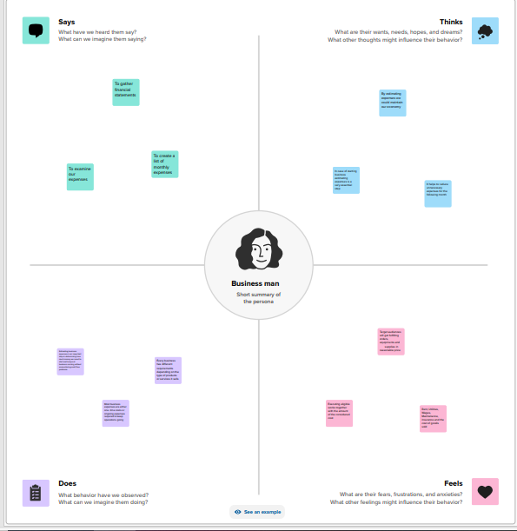

**2.2 Ideation and Brainstorming map**

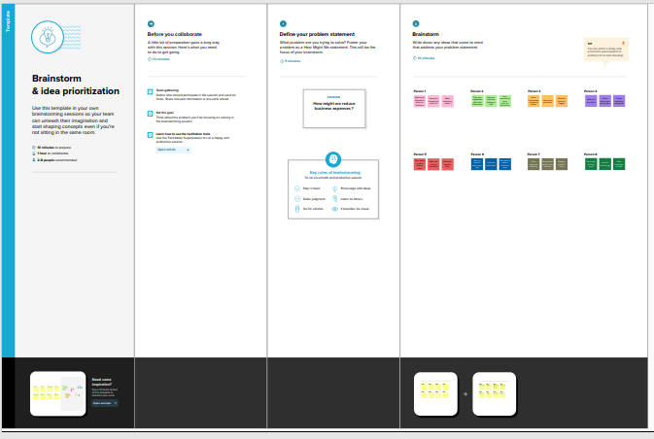

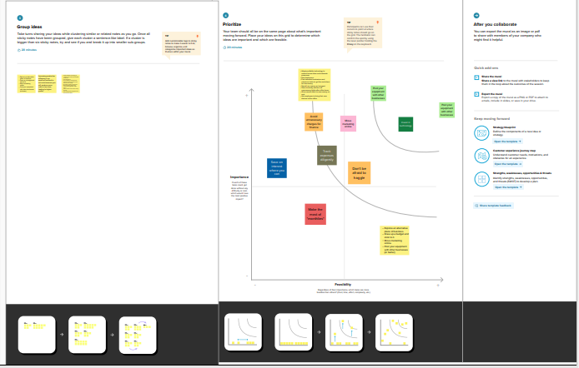

**3 RESULTS**

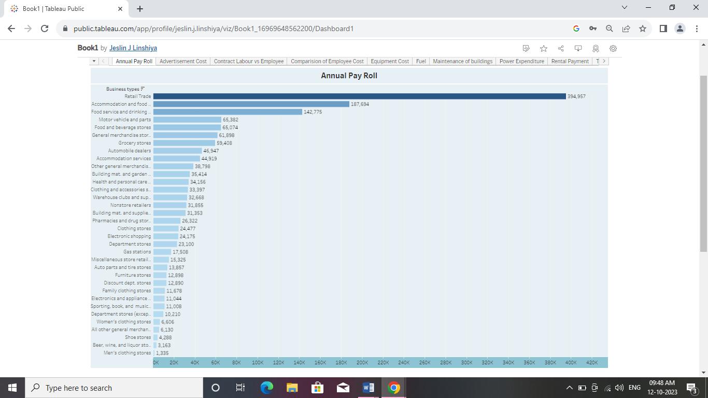

This is the annual pay roll. Payroll includes all forms of compensation, such as salaries, wages, commissions, dismissal pay, bonuses, vacation allowances, sick-leave pay, and employee contributions to qualified pension plans paid during the year to all employees.

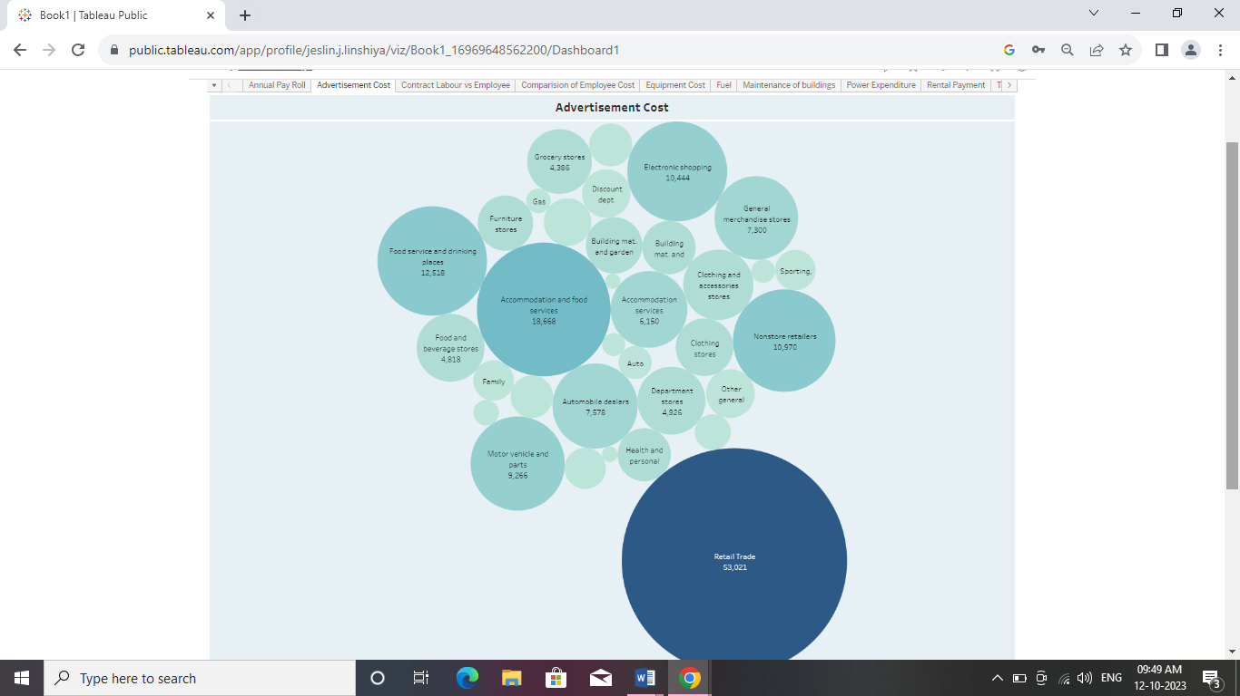

This is the advertisement cost of business. The advertising cost is the total amount of your online advertising costs and offline advertising costs. This metric is very important in order to manage your marketing budget or ad budget. This covers expenses such as cover ads in print media and online venues, broadcast time, radio time, and direct mail advertising.

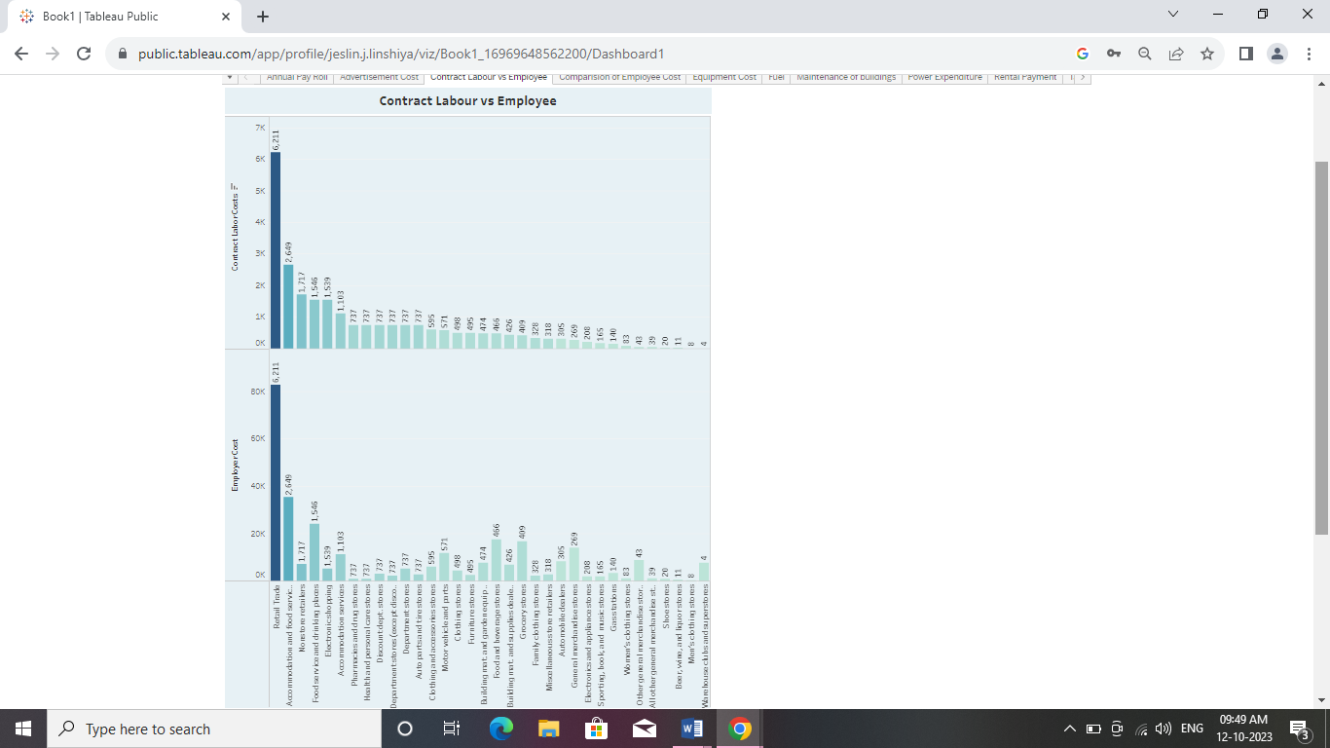

A contractor is an independent worker who has autonomy and flexibility but does not receive employer-provided benefits such as health insurance and paid time off. An employee is on a company's payroll and receives wages and benefits in exchange for following the organization's guidelines and remaining loyal. Both the category have different paying costs.

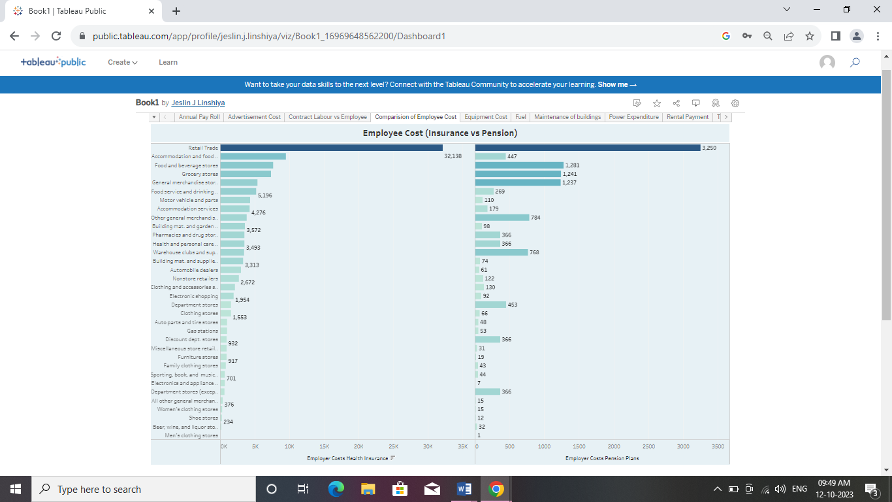

Insurance companies offer insurance policies and annuities, which can be financial instruments. Pension funds use a variety of different financial instruments to invest across different asset allocations.

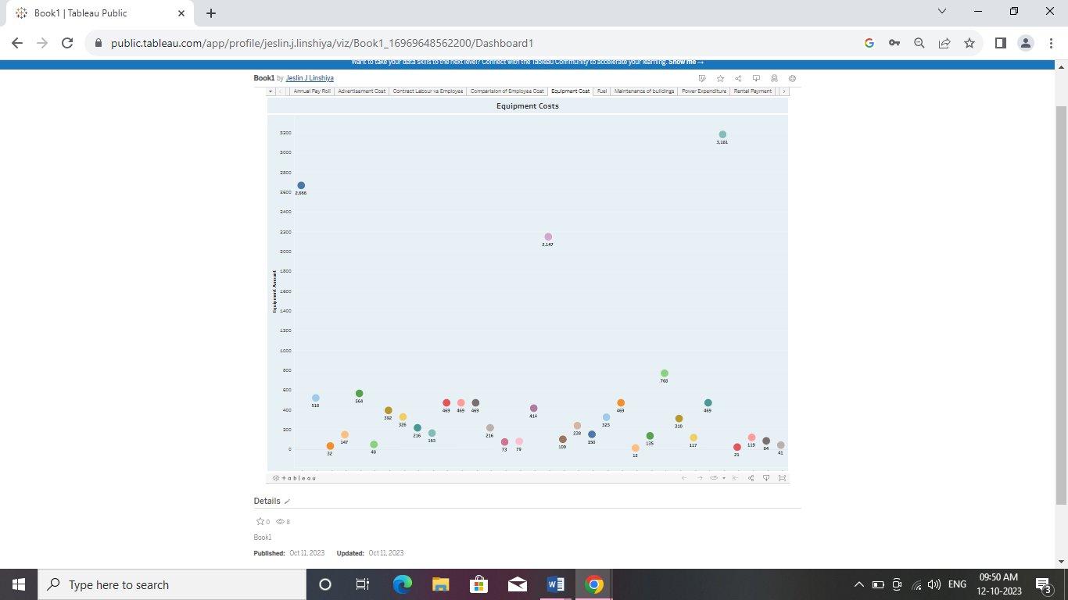

Equipment Costs means the total cost of the Equipment, including related costs such as freight, installation and taxes, capitalizable costs, and costs of issuance incurred in connection with the acquisition and/or financing of the Equipment.

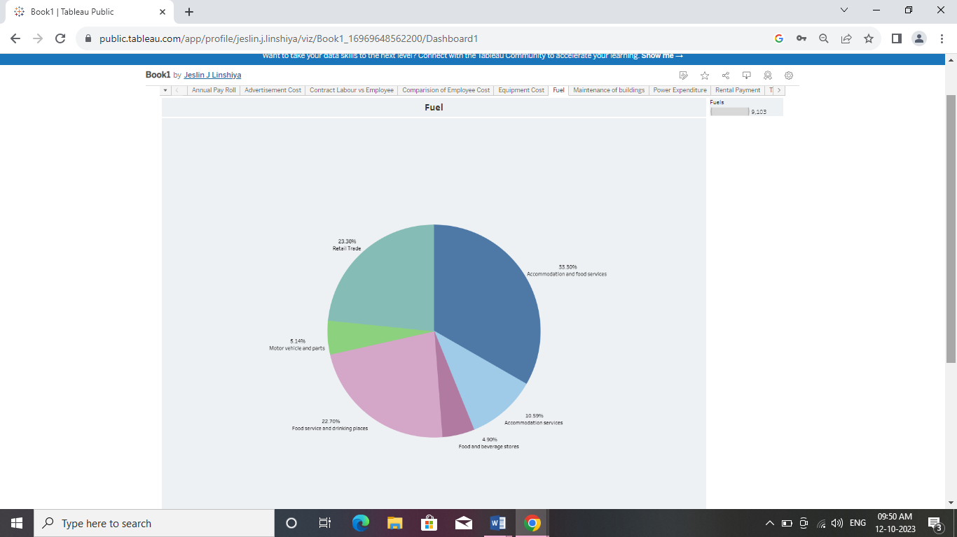

For businesses that sell products or goods, fuel may be considered a cost of goods sold (COGS). This is because fuel is often used in the production or transportation of the goods being sold.

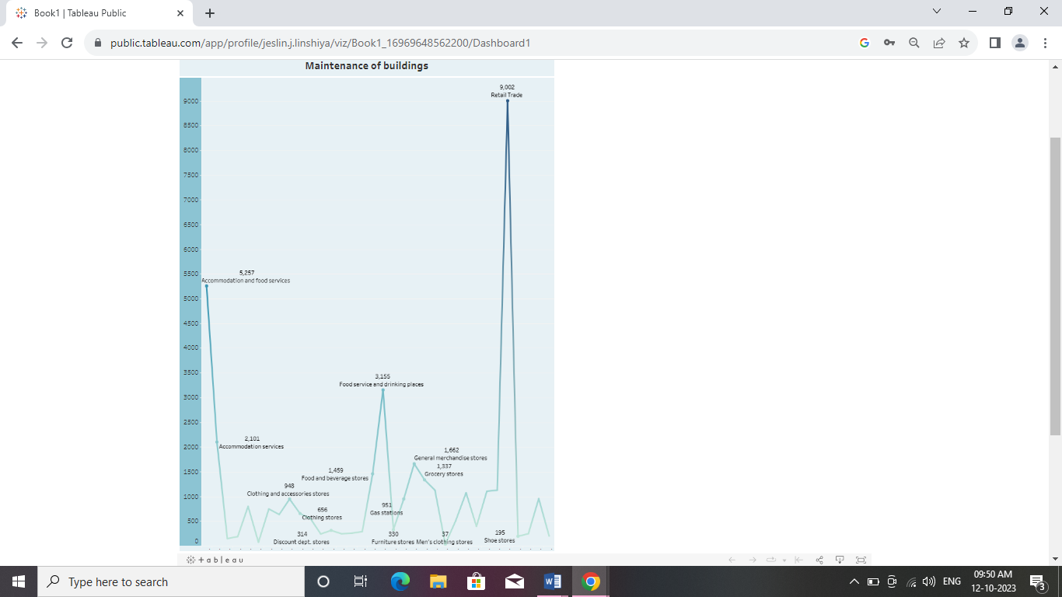

Maintenance is the process of making sure that commercial buildings are safe, functional, and cost effective. Improperly maintained buildings can lead to big problems.To keep the structure in a Good Appearance and working condition at all weathering conditions. To increase the service life of structure & maintain its value. To ensure the safety of Occupants & reduce outgoing expenses. For early identification of defects in the structure.

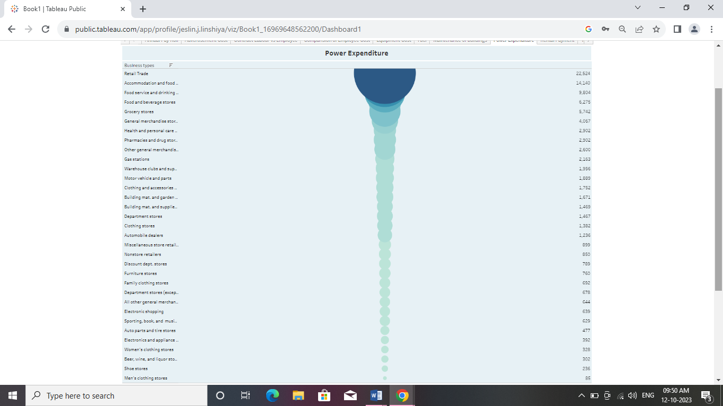

Power Expenditure means all costs incurred in any calendar year in providing electricity for leasable space in the Building, except for costs of electrical consumption by tenants of other space in the Building for which electrical consumption is measured by separate meters.For businesses that use electricity for heating or cooling, such as retail businesses, electricity is likely to be classified as a utility expense. This is because it is a cost that is necessary to maintain the premises in a comfortable environment for customers and staff.

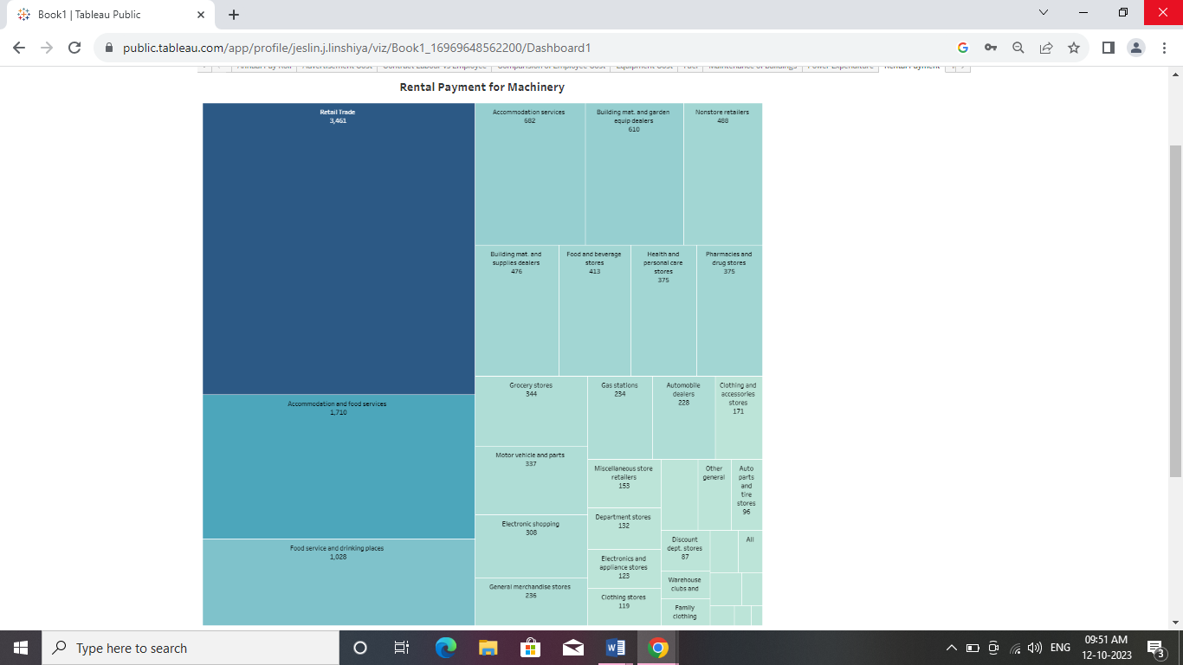

Rental payments are payments made by a tenant to a landlord or property owner for the use of a rental property, such as a company space, an apartment, or a house. The rental payment amount is typically agreed upon in a written lease agreement, which is a legally binding contract between the landlord and tenant.

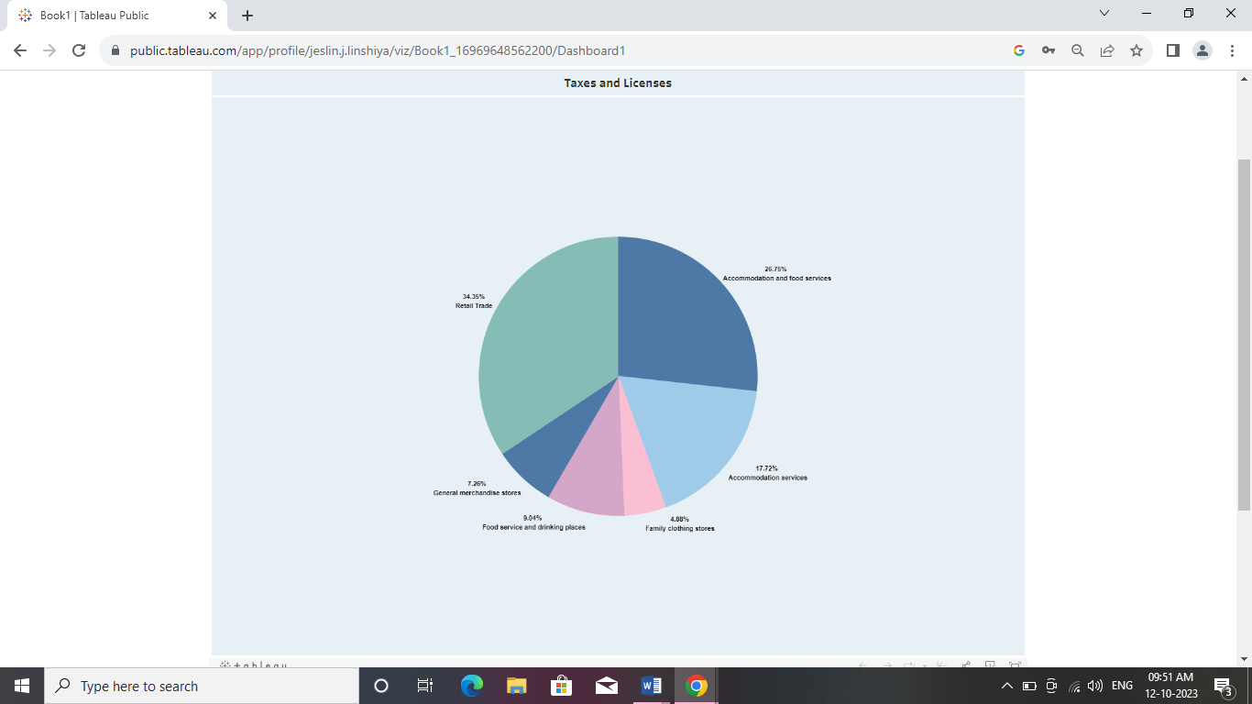

A business company's tax expense, or tax charge, is the income before tax multiplied by the appropriate tax rate. Generally, companies report income before tax to their shareholder under generally accepted accounting principles . However, companies report income before tax to their government under tax law. Business expenses are incurred as part of a company’s operations. Businesses subtract their expenses from their revenue to determine their net profit or loss and taxable income. An expense must be considered as ordinary and necessary by the IRS to be tax-deductible.

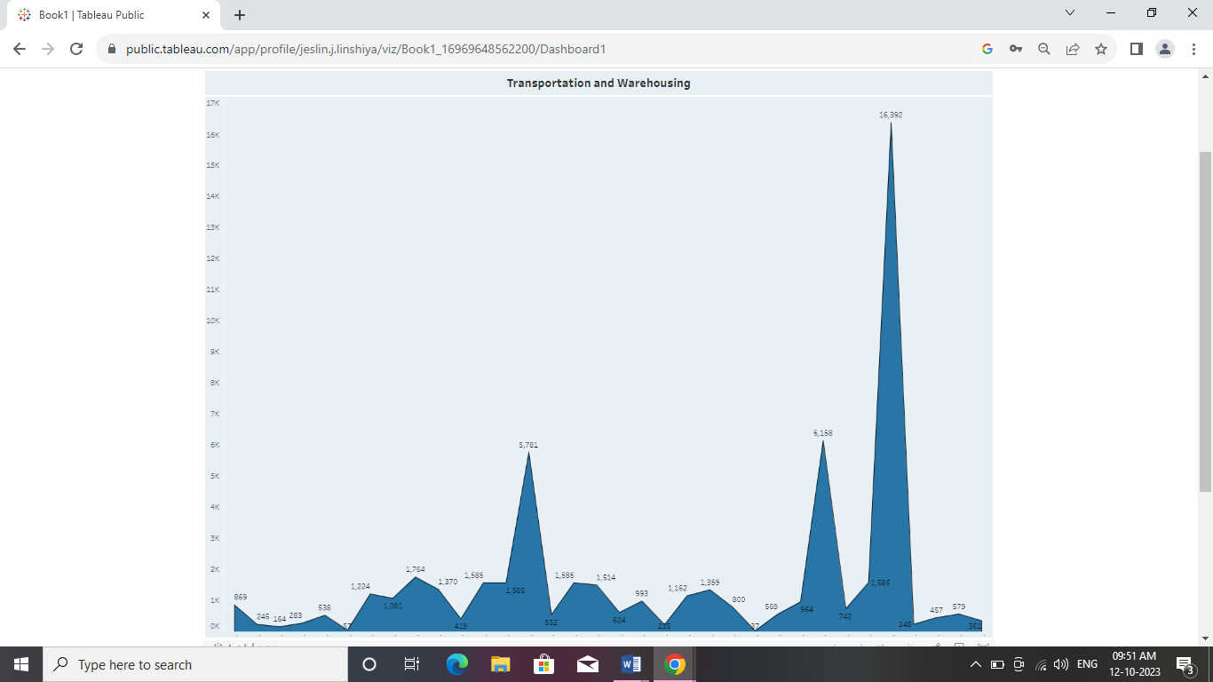

Transportation expenses are a subset of travel expenses that refer specifically to the cost of business transportation by car, plane, train, etc. Expenses such as fuel, parking fees, lodging, meals, and telephone charges incurred by employees can be claimed as transportation expenses.Warehousing costs refer to the fees associated with operating a warehouse, such as rent, utilities, labor, insurance, maintenance, and taxes. It also includes the cost of goods stored in the warehouse, including the cost of inventory control, order fulfillment, and other related services.

1. **ADVANTAGES AND DISADVANTAGES**

**4.1 Advantages**

* It provides a clear account for budgeting and makes it easier.
* Asset values are effective and can be easily verified.
* It does not require updating regularly.
* It helps the management to make effective decisions.

**4.2 Disadvantages**

* Its maintenance is expensive.
* It does not accurately reflect an asset's current value.
* It does not account for inflation or deflation.
* It is time very consuming.
* Expertise is required to manage.

1. **APPLICATIONS**

**5.1 Applications**

* Determining cost budgets.
* Identifying opportunities for cost savings.
* Schedule the work necessary to manage new resources.
* Winning any new business.
* Analysing data and predict future costs.
* Standard costing, and inventory management.
* Providing a basis for comparing investments or total expected cost.

1. **CONCLUSION**

This estimation of business expenditure is an important process that enables budgetary controls so that there is no running out of money thereby increases the probability of winning new business.It reduces the unexpected expenses in the following month and profitability gets higher providing uninterrupted services.

1. **FUTURE SCOPE**

Expenses estimation focusess on looking tasks, duration, and resources required to forecast a business’ total cost to deliver. It includes decisions about the business’ scope, schedule, and resources. For example, a medical industry may use expenditure estimation to determine the financial requirements for a new medical facility. It helps decide on the specific services that can be provided and the required staff.